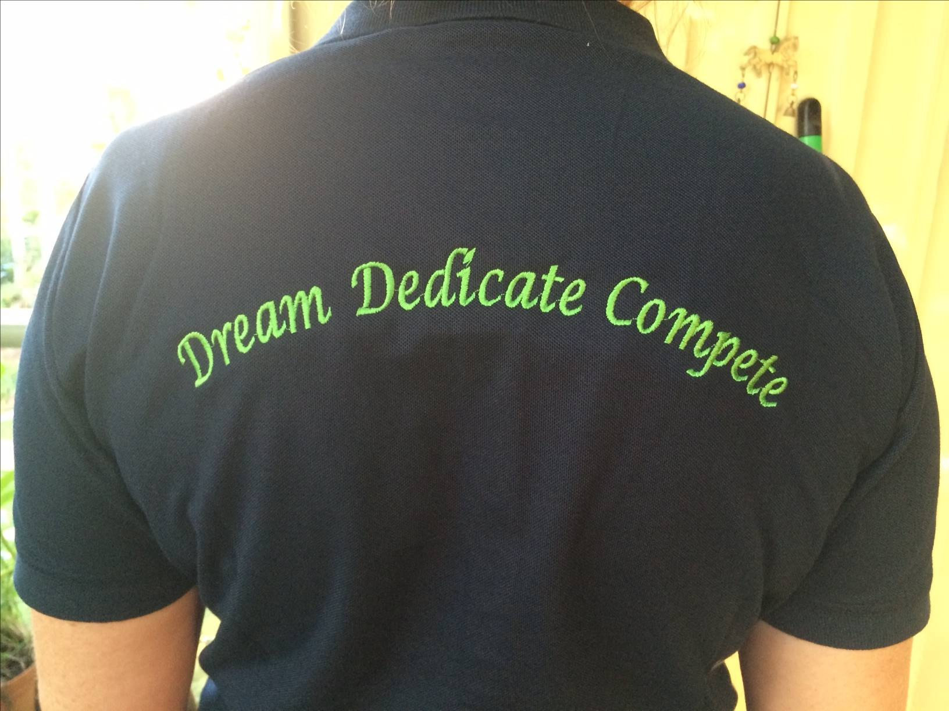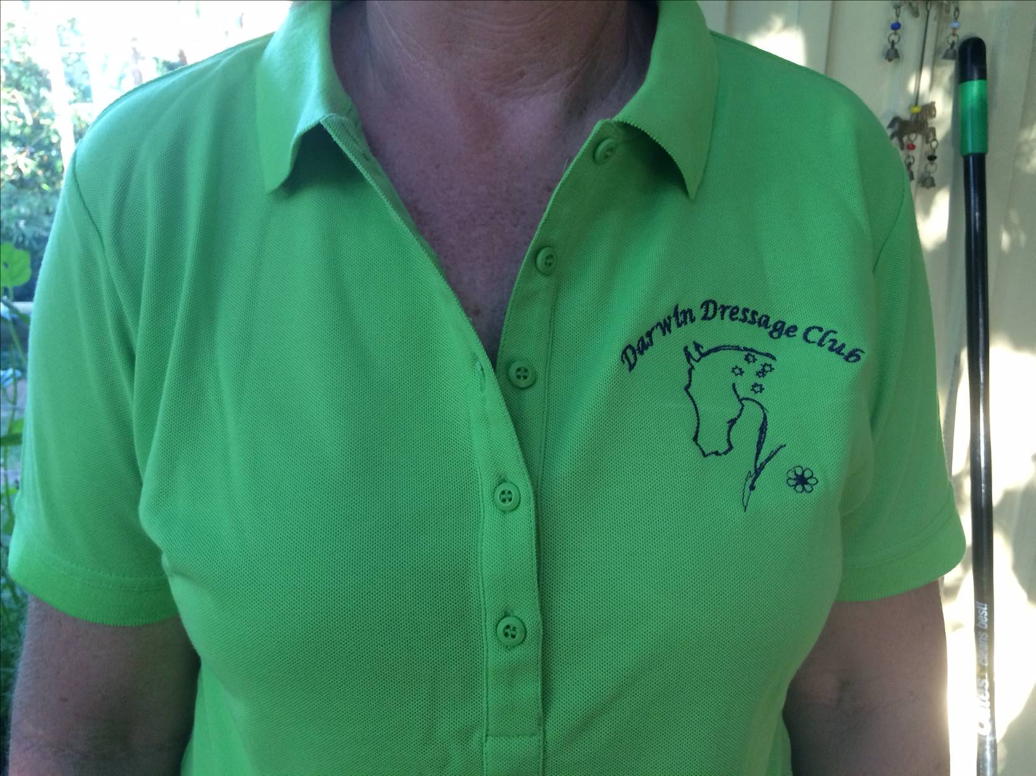

Avaliable colours: Navy and Lime Green (as seen above)
- Easy Fit
- 170GM 60% Cotton , 40% Polyester Moisture Pique Knit Easy Care Fabric
- $38 each

Please complete the following order form and email back to: darwindressageclub@hotmail.com
NAME:
CONTACT NUMBER:
POSTAL ADDRESS
(if required)
NAVY |  | QUANTITY |  |  | SIZE(S)
GREEN |  | QUANTITY |  |  | SIZE(S)
Direct Deposit*:  Bank: Bendigo Bank  BSB: 633 108  Account: 154 483 713  Name of Account: Darwin Dressage Club Inc.  * Please ensure you put your name in the description of the deposit. |  |  |  | Cheque:  Make cheque payable to “Darwin Dressage Club” and post to:  Darwin Dressage Club  PO Box 1706  Coolalinga, NT 0839
Amount payable |  |  |  | $
Postage (if required) |  |  |  | $
TOTAL |  |  |  | $

